|  |  |  |
| --- | --- | --- |
| **Tech Saksham**  Final Project Report  **Track Name** |  |  |

**“IIIT ADMISSION PREDECTION”**

**“RAJIV GANDHI UNIVERSITY KNOWLEDGE OF TECHNOLOGY”**

|  |  |
| --- | --- |
| **ROLL NO** | **NAME** |
| R170070 | P.DHARANI |
| R170270 | S.ARCHANA |
| R170962 | Y.PRASANNA |
| R170953 | G.LOKESWARI |

Trainer Name:P.RAGAVAN

|  |  |
| --- | --- |
|  |  |
|  |  |
|  |  |
|  |  |
|  |  |
|  |  |

**ABSTRACT**

IIIT admission Prediction is very important and plays a key role in Andhra Pradesh students who just passed 10th class. Predicting IIIT admission can be especially difficult because the students are not aware of admission requirements. For that reason, the main purpose of this research work is to provide a recommender system for early predicting IIIT admission.

Therefore, To predict chance of admission first we applied several Supervised Machine Learning algorithms namely Linear Regression, Support Vector Regression, Decision Tree Regression, and Random Forest Regression. Secondly we compared and evaluated algorithms used to create a predictive model based on various evaluation metrics. Lastly we determined the most important parameters that influence the chance of admission.

The experimental results showed that the Linear Regression is the most suitable Machine Learning algorithm for predicting IIIT admission

**INDEX**

|  |  |  |
| --- | --- | --- |
| **Sr. No.** | **Table of Contents** | **Page No.** |
| 1 | Chapter 1: Introduction | 1-2 |
| 2 | Chapter 2:Literacy survey | 2-5 |
| 3 | Chapter 3: linear regression | 5-7 |
| 4 | Chapter 4: Implementation | 8-14 |
| 5 | Chapter 5: Result | 14-16 |
| 6 | Conclusion | 16 |
| 7 | References | 17 |
| 8 | Code | 17 |

**CHAPTER 1**

**INTRODUCTION**

**1.1 INTRODUCTION**

The number of students applying for IIIT(RGUKT) has increasing year by year. This fact has motivated us to study the grades of students and the chance of admission for IIIT that can help students in predicting the possibility of getting admission in IIIT.

Machine Learning is a subset of Artificial Intelligence (AI) that enables computers to automatically improve through experience. In the area of education, the adoption of Machine Learning is also accelerating.

Using the machine learning algorithms it’s easy to build the prediction model based on the previous year’s admission data.

**1.2 PURPOSE**

The purpose of this document is to gather the requirements that are needed for implementing the IIIT ADMISSION PREDICTION. It also focuses on various key features, the product, product vision and scope, product overview. The main purpose of this model is to provide a Prediction system that predicts the percentage of chance of IIIT admission.

**1.3 INTENDED AUDIENCE**

The intended audience will be the **students** who are interested to join IIIT. They can know the percentage of chance of getting admission in IIIT.

**1.4 PRODUCT VISION**

**Vision Statement:**

The product vision is to develop a Prediction System which is user friendly and accurate enough to predict the percentage of chance of admission of a student into IIIT. By using this system students can early predict the admission.

**1.5 TECHNOLOGIES**

* Machine Learning for Prediction System
* HTML, CSS for UI
* Flask for backend

**CHAPTER 2**

**LITERATURE SURVEY**

**2.1 REGRESSION**

As we are predicting the percentage of chance of admission, the output (Dependent) variable is continuous variable. We have to use the **Regression** techniques in **Supervised Algorithms** to predict the continuous variable.

**Types of Regression Algorithms used for Prediction:**

**Linear Regression (LR):** It is the most important algorithm in the field of Machine Learning, especially supervised learning. It is a way to model a relationship between a dependent variable and one or more independent variables. It consists of finding a regression line straight line through the points.

**1.Random Forest Regression (RFR):**  it is an ensemble learning method that constructs a multitude of decision trees at training time and uses the average prediction of the individual trees to improve the prediction

**2.Support Vector Regression (SVR)**: It is also a very popular Machine Learning technique used in both classification and regression. It is similar to Linear Regression with only a few minor differences. SVR allows defining how much error is acceptable in our predictive model and will find an appropriate line to fit the data

**3.Decision Tree (DT)**: It is the most widely used classification and prediction technique. It is a tree structure, where each internal node with outgoing edges indicates a condition on an attribute, each branch is an outcome of the test, and each leaf terminal node represents a class label

**2.2 EVALUATION METRICS**

The main part of building a Machine Learning model is Evaluation of model. There are many methods of evaluation that can be used. While building our model we have used the below two metrics for the evaluation part.

**R-Squared (R2 or the coefficient of determination)** :

1. R-squared is a statistical method that determines the goodness of fit.
2. It measures the strength of the relationship between the dependent and independent variables on a scale of 0-100%.
3. The high value of R-square determines the less difference between the predicted values and actual values and hence represents a good model.
4. It is also called a **coefficient of determination,** or **coefficient of multiple determination** for multiple regression.
5. It can be calculated from the below formula:
6. 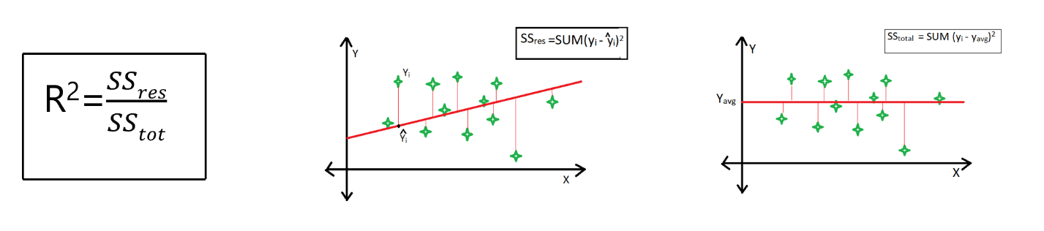
7. Fig 2.21

## Where,

1. SSres = summation of squares of perpendicular distance between data points and the best-fitted line.
2. SStot = summation of squares of perpendicular distance between data points and the average lines.
3. **Mean Square Error (MSE):**

## It is the arithmetic mean of the squares of the predictions between the model and the observations. This is the value to be minimized in the context of a single or multiple regressions. It measures the average of error squares i.e. the average squared difference between the estimated values and true values. It is a risk function, corresponding to the expected value of the squared error loss.

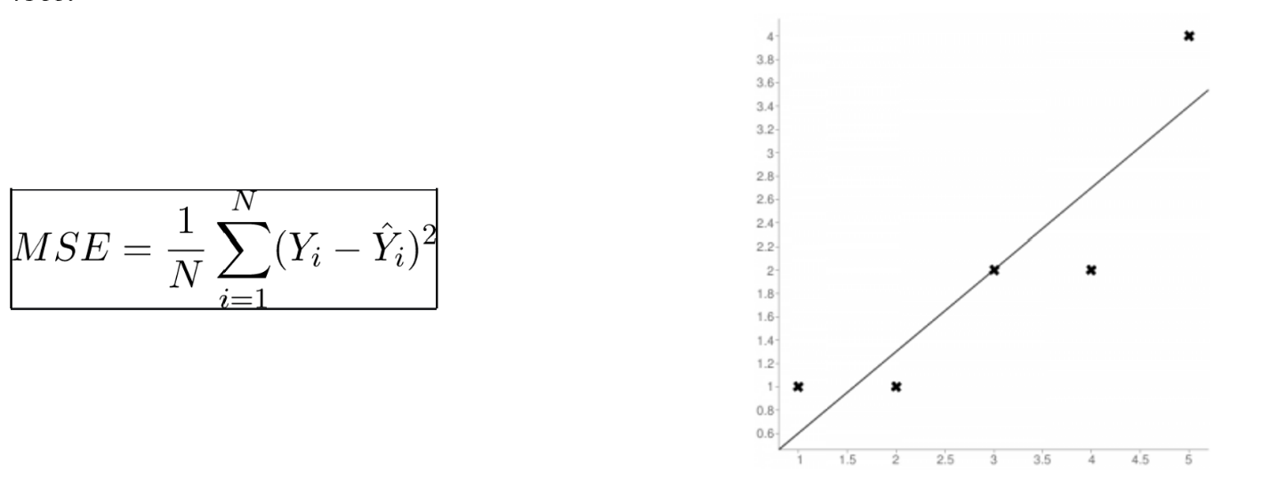

Fig.2.22

**n =** Total no. of data points

Yi = Actual Output Value

Y^I = Predicted Output Value

## **2.3 INITIAL RESULT OF ALGORITHMS**

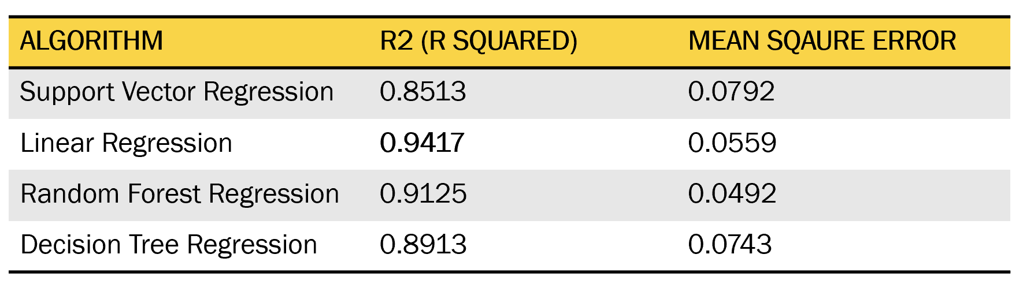

Fig.2.33

**CHAPTER 3**

**LINEAR REGRESSION**

Linear regression is a machine learning algorithm based on **supervised learning**. It performs a **regression task**. Regression models a target prediction value based on independent variables. It is mostly used for finding out the relationship between variables and forecasting. Different regression models differ based on – the kind of relationship between dependent and independent variables they are considering, and the number of independent variables getting used Linear regression performs the task to predict a dependent variable value (y) based on a given independent variable (x). So, this regression technique finds out a linear relationship between x (input) and y(output). Hence, the name is Linear Regression.  
In the figure above, X (input) is the work experience and Y (output) is the salary of a person. The regression line is the best fit line for our model. When there is a single input variable (x), the method is referred to as **simple linear regression**. When there are **multiple input variables**, literature from statistics often refers to the method as multiple linear regression

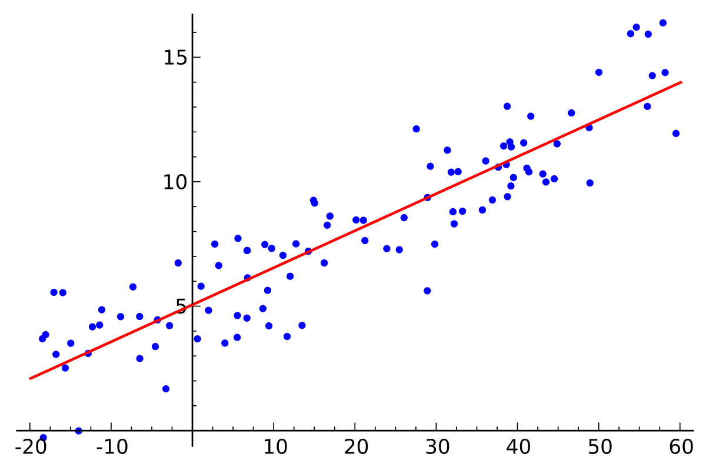

**3.1 HYPOTHESIS FUNCTION FOR LINEAR REGRESSION**

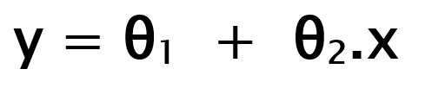

Fig.3.11

Where,

While training the model we are given :  
**X:**input training data (one input variable)  
**y:** labels to data (supervised learning)

When training the model – it fits the best line to predict the value of y for a given value of x. The model gets the best regression fit line by finding the best θ1and θ2values.

**θ1:**intercept  
**θ2:**coefficient of x

Once we find the best θ1 and θ2values, we get the best fit line. So when we are finally using our model for prediction, it will predict the value of y for the input value of x.

## **3.2 FINDING THE BEST FIT LINE:**

When working with linear regression, our main goal is to find the best fit line that means the error between predicted values and actual values should be minimized. The best fit line will have the least error.The different values for weights or the coefficient of lines (a0, a1) gives a different line of regression, so we need to calculate the best values for a0 and a1 to find the best fit line, so to calculate this we use cost function.

## **3.3 COST FUNCTION:**

Cost function is the calculation of error between predicted values and actual values, represented as a single real number.

* The different values for weights or coefficient of lines (**θ1**, **θ2**) gives the different line of regression, and the cost function is used to estimate the values of the coefficient for the best fit line.
* Cost function optimizes the regression coefficients or weights. It measures how a linear regression model is performing.
* We can use the cost function to find the accuracy of the **mapping function**, which maps the input variable to the output variable. This mapping function is also known as **Hypothesis function**

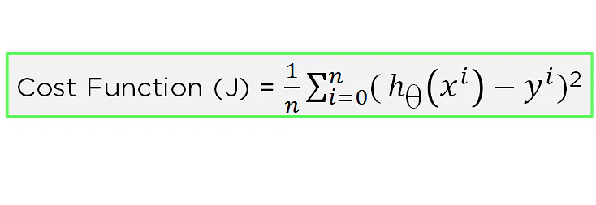

Fig.3.3

**CHAPTER-4**

**IMPLEMENTATION**

**4.1 PROPOSED SYSTEM**

* The students who completed tenth class have more curiosity and confusion whether they get admission in IIIT or not. At present there is no system available to help these students.
* So in this model we have proposed ‘IIIT Admission Prediction System’ which predicts the percentage of chance of getting admission into IIIT.

**4.2 WORKING MODEL**

PREDICTION SYSTEM

**Linear Regression**

STUDENT DATA CHANCE OF ADMISSION

PREDICTION SYSTEM

Fig 4.2

This Proposed System is built in following steps

1. Data Collection
2. Data Pre-processing
3. Model Building

I used Jupyter notebook tool for this model building.

**4.21 DATA COLLECTION**

Initially I have collected the previous data related to admissions of IIIT and stored it in CSV file.

After importing proper modules access the dataset using read_csv method.

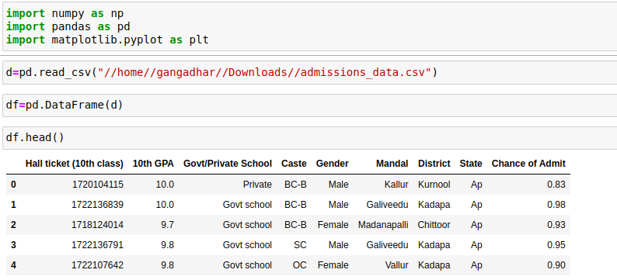

**4.22 DATA FEATURES**

Given below table shows the data type of each attribute in our dataset

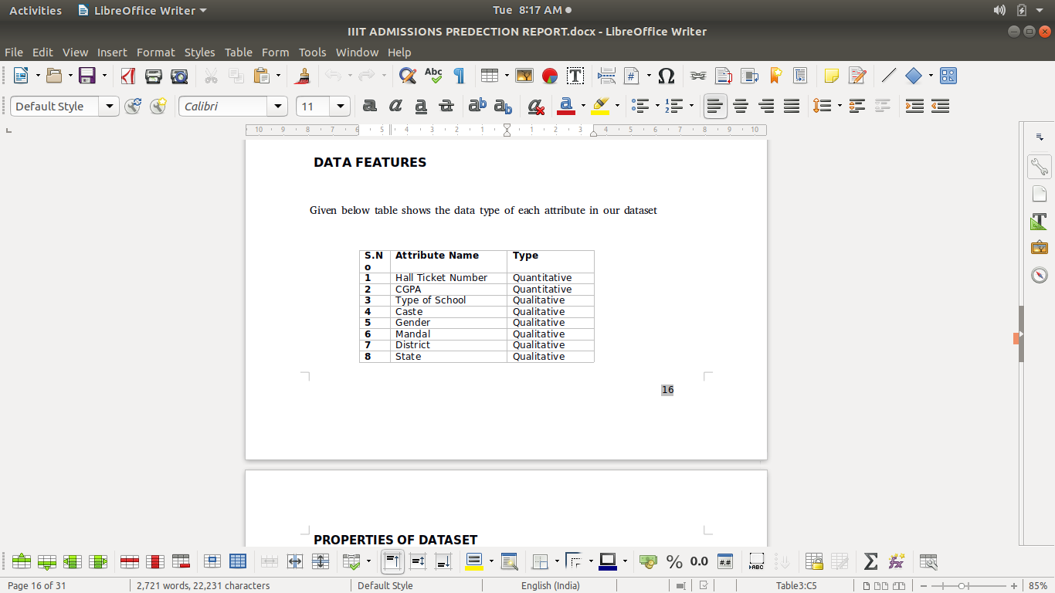

**PROPERTIES OF DATASET**

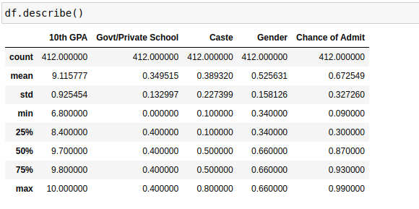

**4.3 DATA PRE-PROCESSING**

It represents one of the most crucial steps in all Machine Learning projects because it involves formatting data, Improving data quality, feature engineering, and labelling .

Firstly we need to process the data such that there will be no null values and duplicate values.

In the given data set there are so many parameters that are of type String. We need to convert this type into numeric values for further processing.

After doing this, add a new parameter called ‘Performance Score’ by adding caste, CGPA, school type and gender.

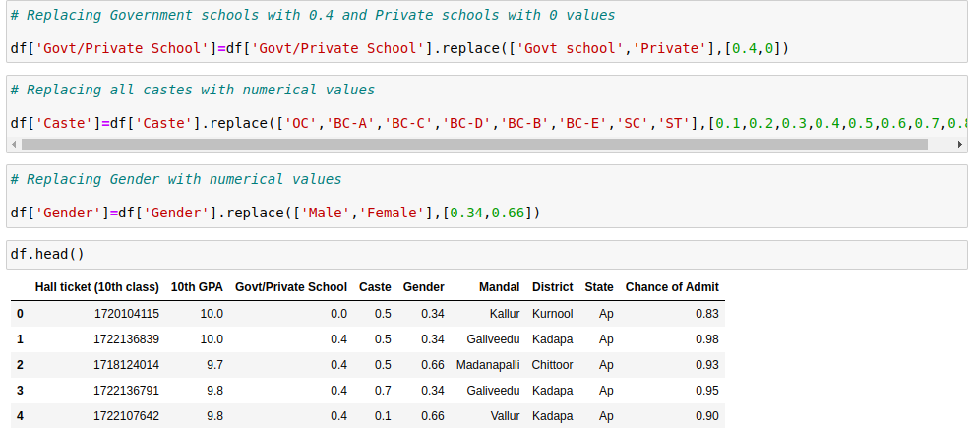

**4.31 CALCULATING PERFORMANCE SCORE**

Performance score is calculated to plot against chance of admit.

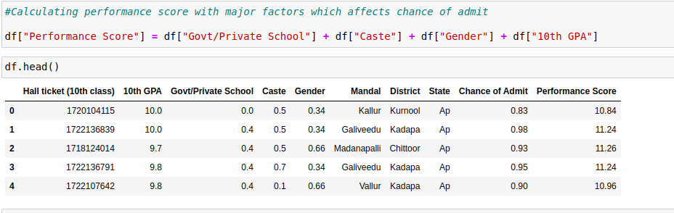

Finding Relationship between independent variables and dependent variable

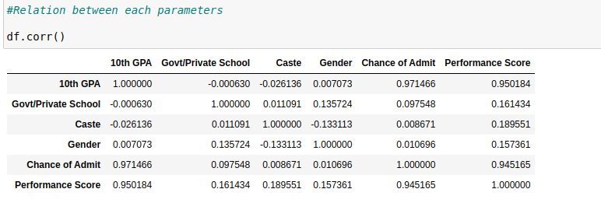

From the relationship table we can see that CGPA and Performance Score is highly related on Chance of Admit. But Performance Score is depended on cgpa,caste,school type and gender.

Now plot the relation between Performance Score and Chance of Admit.

**4.32 GRAPH**

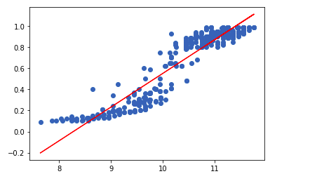

Fig.4.32

**4.33 MODEL BUILDING**

As the final dataset is ready, now we can build our model.

Import the Linear Regression model from sklearn module.Divide the dataset into two parts such as Test data and Train Data.

Now train the test data using train data by fitting into Linear Regression Model.

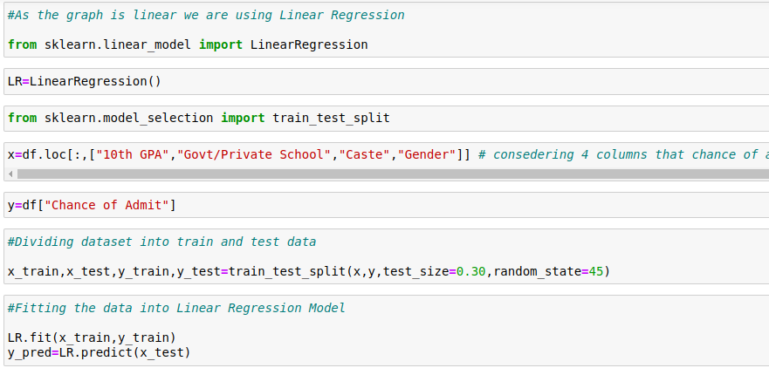

Fig.

Now the predection model built sucessfully.

**4.4 EVALUATION METRIC**

**Calculating R2 score and Mean Square Error of the Model** 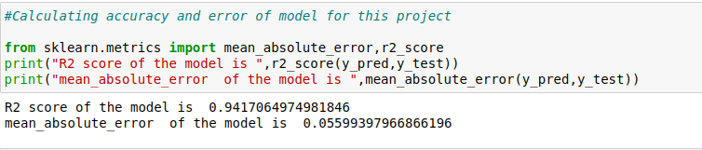

We can see that our built model got **R2 Score** of **0.9417** which is quite good.**Mean Absolute Error** is **0.055.** Our prediction model is ready and now we can use it.

**CHAPTER 5**

**RESULT**

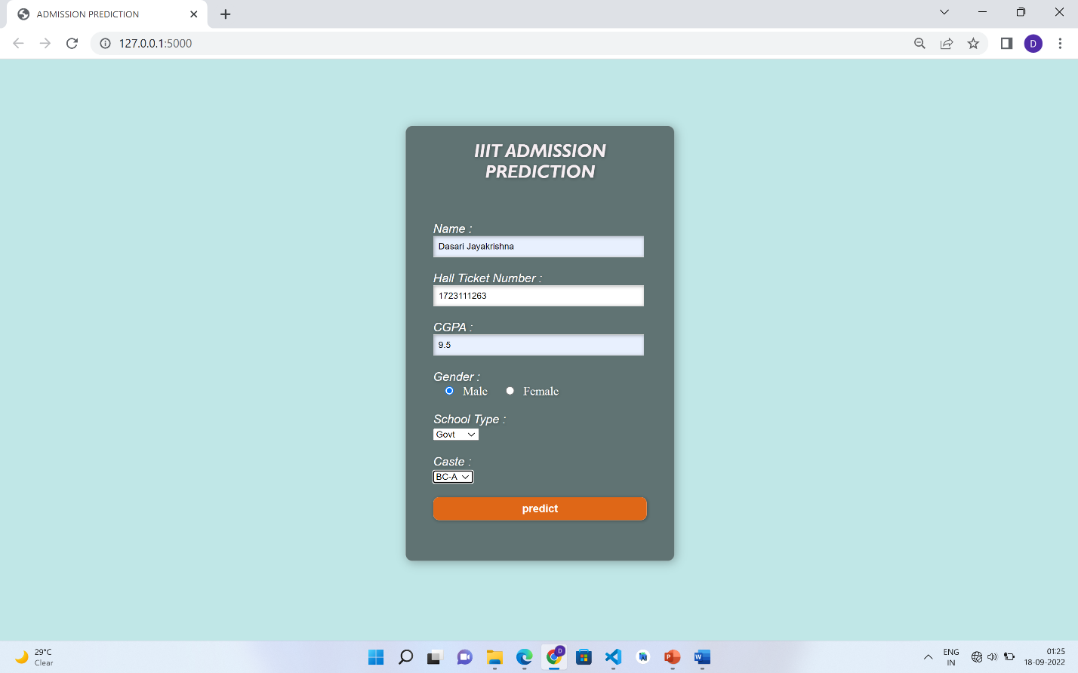

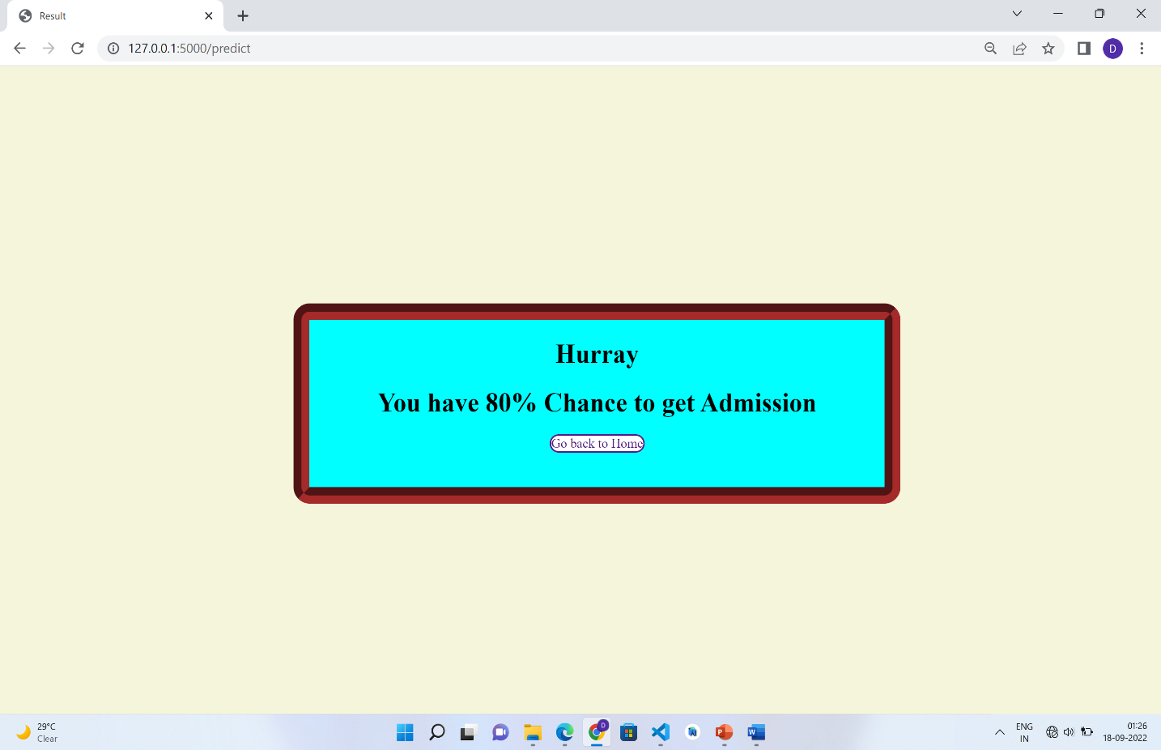

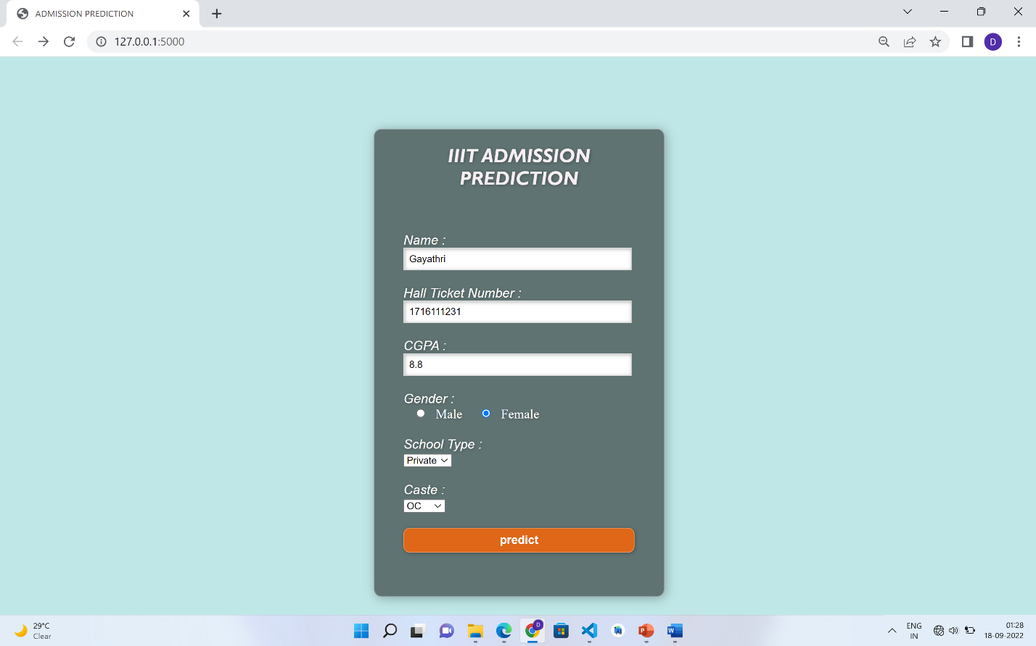

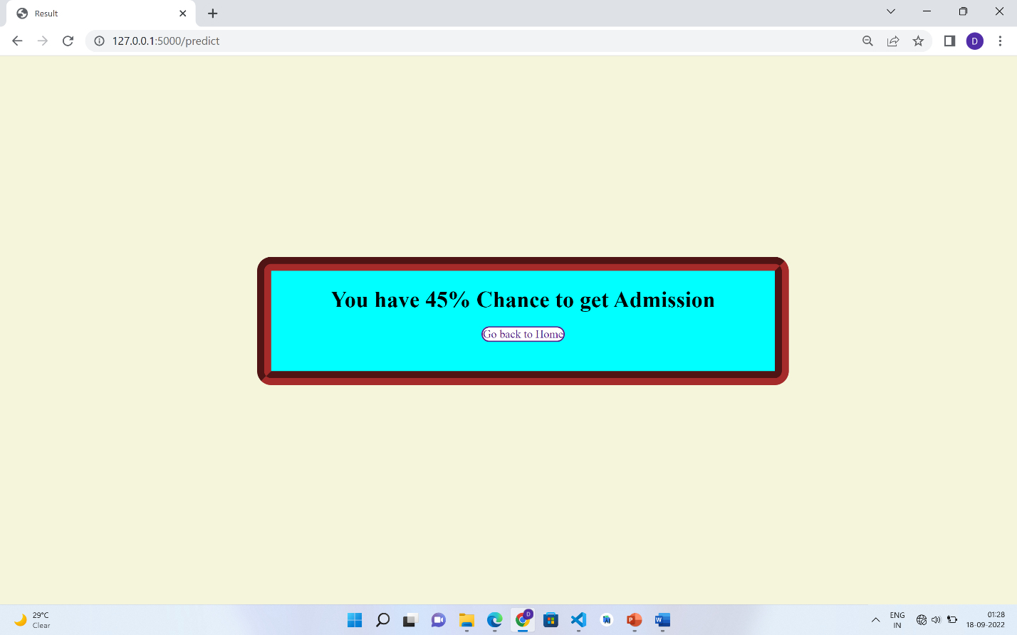

**CHAPTER 6**

**CONCLUSION**

**6..1 CONCLUSION**

In this project we used Linear Regression algorithm to provide percentage of chance of getting admission in IIIT to the students. Here we used previous year’s date to train the model and testing.

Students may not have clear idea about selection process and attributes which effects admission more. Whenever student enter his details, the model gives the prediction based on similar previous data. So that students will know their chance and don’t waste their time in waiting for the results. Students who have less chance they can proceed with other alternatives.

**6.2 FUTURE ENHANCEMENTS**

We will be considering option of special candidates like NCC,CAP,PH etc. There will be more priority for these special candidates, so automatically chance of admission for these candidates increases.We will also try to improve the interface more interactive i.e. queries section, help section etc.

**CHAPTER 7**

**REFERENCES**

[1] GeeksForGeeks : <https://www.geeksforgeeks.org/ml-linear-regression/>

[2] Scikit Learn : <https://scikitlearn.org/stable/modules/generated/sklearn.model_selection.train_test_split.html>

**[3] Javatpoint :** [**https://www.javatpoint.com/machine-learning**](https://www.javatpoint.com/machine-learning)

**CHAPTER 8**

**CODE**

**https://github.com/Archana-12345/techsaksham_project.git**